**Assignment 11.6**

1. **Find the top five kinds of GoogleKnowlege_Occupation people who were guests in the show, in a particular time period i.e., between '1/11/99' and 6/11/99. You need to write an UDF to compare the dates.**

**UDF:**

Used Date to filter date between '1/11/99' and 6/11/99 by using date.after and date.before function

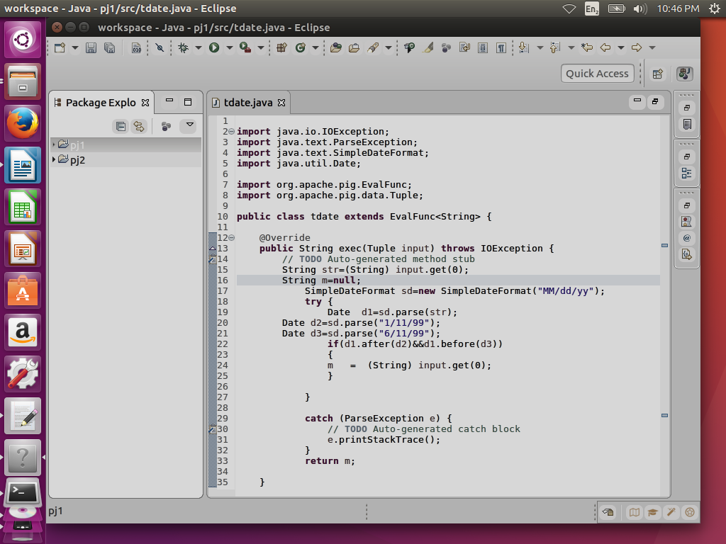

**Pig commands**

**Step 1:** REGISTERING UDF

**Step2:** Generating Google knowledge column and used tdate(date column);

**Step3:** filter it for not null condition

**Step4:** made group by Google knowledge occupation

**Step5:** made count

**Step6:** order by count desc

**Step7:** made limit of 5

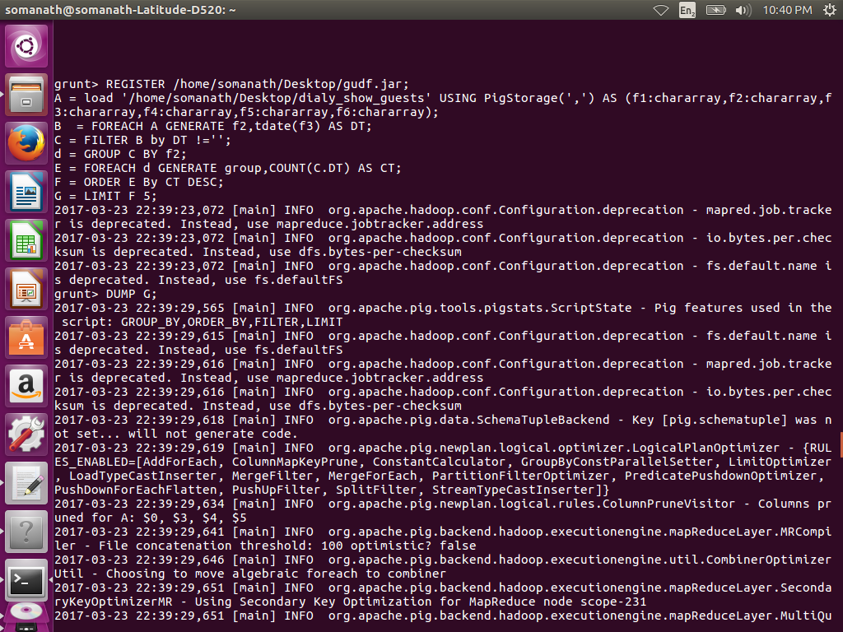

**OUTPUT:**

